1) #include <stdio.h>
#include <string.h>
#define MAX_CHAR 256
void characterFrequency(const char *s) {
int frequency[MAX_CHAR] = {0};
for (int i = 0; s[i] != '\0'; i++) {
frequency[(unsigned char)s[i]]++;
}
for (int i = 0; i < MAX_CHAR; i++) {
if (frequency[i] > 0) {
printf("%c -> %d\n", i, frequency[i]);
}
}
}
int main() {
const char *s = "tree";
characterFrequency(s);
return 0;
}
Output:
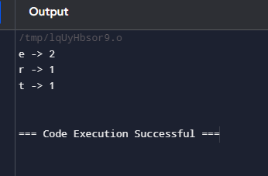

2) #include <stdio.h>
#include <stdlib.h>
int segregate(int arr[], int size) {
int j = 0;
for (int i = 0; i < size; i++) {
if (arr[i] <= 0) {
int temp = arr[i];
arr[i] = arr[j];
arr[j] = temp;
j++;
}
}
return j;
}
int findMissingPositive(int arr[], int size) {
for (int i = 0; i < size; i++) {
int absVal = abs(arr[i]);
if (absVal - 1 < size && arr[absVal - 1] > 0) {
arr[absVal - 1] = -arr[absVal - 1];
}
}
for (int i = 0; i < size; i++) {
if (arr[i] > 0) {
return i + 1;
}
}
return size + 1;
}
int findSmallestMissingPositive(int arr[], int size) {
int shift = segregate(arr, size);
return findMissingPositive(arr + shift, size - shift);
}

int main() {
int arr1[] = {2, 3, 7, 6, 8, -1, -10, 15};
int size1 = sizeof(arr1) / sizeof(arr1[0]);
printf("The smallest missing positive number is %d\n", findSmallestMissingPositive(arr1, size1));
int arr2[] = {2, 3, -7, 6, 8, 1, -10, 15};
int size2 = sizeof(arr2) / sizeof(arr2[0]);
printf("The smallest missing positive number is %d\n", findSmallestMissingPositive(arr2, size2));
int arr3[] = {1, 1, 0, -1, -2};
int size3 = sizeof(arr3) / sizeof(arr3[0]);
printf("The smallest missing positive number is %d\n", findSmallestMissingPositive(arr3, size3));
return 0;
}
Output:
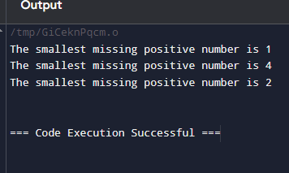

3) #include <stdio.h>
#include <stdlib.h>
struct TreeNode {
int val;
struct TreeNode *left;
struct TreeNode *right;
};
int search(int *inorder, int start, int end, int value) {
for (int i = start; i <= end; i++) {
if (inorder[i] == value) {
return i;
}
}
return -1;
}
struct TreeNode* buildTreeHelper(int* preorder, int* inorder, int inorderStart, int inorderEnd, int* preorderIndex) {
if (inorderStart > inorderEnd) {
return NULL;
}
int rootValue = preorder[*preorderIndex];
(*preorderIndex)++;
struct TreeNode* root = (struct TreeNode*)malloc(sizeof(struct TreeNode));
root->val = rootValue;
root->left = NULL;
root->right = NULL;
if (inorderStart == inorderEnd) {
return root;
}
int inorderIndex = search(inorder, inorderStart, inorderEnd, rootValue);
root->left = buildTreeHelper(preorder, inorder, inorderStart, inorderIndex - 1, preorderIndex);
root->right = buildTreeHelper(preorder, inorder, inorderIndex + 1, inorderEnd, preorderIndex);
return root;
}
struct TreeNode* buildTree(int* preorder, int preorderSize, int* inorder, int inorderSize) {
int preorderIndex = 0;
return buildTreeHelper(preorder, inorder, 0, inorderSize - 1, &preorderIndex);
}
void printLevelOrder(struct TreeNode* root) {
if (!root) return;
struct TreeNode* queue[100];
int front = 0, rear = 0;
queue[rear++] = root;
while (front < rear) {
struct TreeNode* currentNode = queue[front++];
if (currentNode) {
printf("%d ", currentNode->val);
queue[rear++] = currentNode->left;
queue[rear++] = currentNode->right;
} else {
printf("null ");
}
}
}
int main() {
int preorder[] = {3, 9, 20, 15, 7};
int inorder[] = {9, 3, 15, 20, 7};
int preorderSize = sizeof(preorder) / sizeof(preorder[0]);
int inorderSize = sizeof(inorder) / sizeof(inorder[0]);
struct TreeNode* root = buildTree(preorder, preorderSize, inorder, inorderSize);
printf("Level Order Output of the Tree: ");
printLevelOrder(root);
return 0;
}
Output:
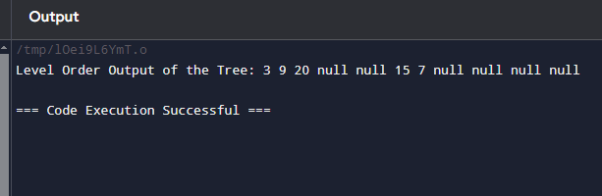
4) #include <stdio.h>
#include <stdlib.h>
struct Node {
int data;
struct Node* next;
};
struct Node* createNode(int data) {
struct Node* newNode = (struct Node*)malloc(sizeof(struct Node));
newNode->data = data;
newNode->next = NULL;
return newNode;
}
void appendNode(struct Node** head, int data) {
struct Node* newNode = createNode(data);
if (*head == NULL) {
*head = newNode;
} else {
struct Node* temp = *head;
while (temp->next != NULL) {
temp = temp->next;
}
temp->next = newNode;
}
}
void displayList(struct Node* head) {
struct Node* temp = head;
while (temp != NULL) {
printf("%d", temp->data);
temp = temp->next;
if (temp != NULL) {
printf("->");
}
}
printf("\n");
}
int main() {
struct Node* head = NULL;
appendNode(&head, 6);
appendNode(&head, 7);
appendNode(&head, 8);
appendNode(&head, 9);
printf("Linked List: ");
displayList(head);
return 0;
}
Output:
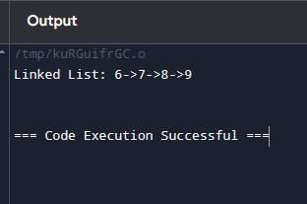

5) #include <stdio.h>
void bubbleSortDescending(int arr[], int n) {
int i, j, temp;
for (i = 0; i < n - 1; i++) {
for (j = 0; j < n - i - 1; j++) {
if (arr[j] < arr[j + 1]) {
temp = arr[j];
arr[j] = arr[j + 1];
arr[j + 1] = temp;
}
}
}
}
void printArray(int arr[], int n) {
for (int i = 0; i < n; i++) {
printf("%d", arr[i]);
if (i < n - 1) {
printf(",");
}
}
printf("\n");
}
int main() {
int arr[] = {4, 7, 9, 1, 2};
int n = sizeof(arr) / sizeof(arr[0]);
printf("Original array: ");
printArray(arr, n);
bubbleSortDescending(arr, n);
printf("Sorted array in descending order: ");
printArray(arr, n);
return 0;
}
Output:
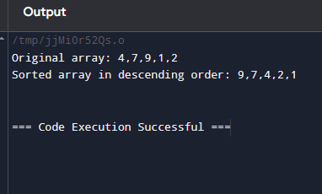

6) #include <stdio.h>
int findMissingNumber(int arr[], int n) {
int expectedSum = n * (n + 1) / 2;
int actualSum = 0;
for (int i = 0; i < n - 1; i++) {
actualSum += arr[i];
}
return expectedSum - actualSum;
}
int main() {
// Example 1
int arr1[] = {1, 2, 3, 5};
int n1 = 5;
printf("Missing number in array 1: %d\n", findMissingNumber(arr1, n1));
int arr2[] = {6, 1, 2, 8, 3, 4, 7, 10, 5};
int n2 = 10;
printf("Missing number in array 2: %d\n", findMissingNumber(arr2, n2));
return 0;
}
Output:
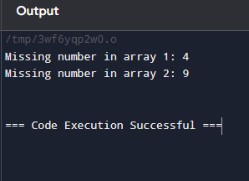

7) #include <stdio.h>
#include <stdlib.h>
typedef struct Node {
int data;
struct Node* next;
} Node;
Node* createNode(int data) {
Node* newNode = (Node*)malloc(sizeof(Node));
if (newNode == NULL) {
printf("Memory allocation failed\n");
exit(1);
}
newNode->data = data;
newNode->next = NULL;
return newNode;
}
void printOddNumbers(Node* head) {
Node* current = head;
while (current != NULL) {
if (current->data % 2 != 0) {
printf("%d ", current->data);
}
current = current->next;
}
printf("\n");
}
void appendNode(Node** head, int data) {
Node* newNode = createNode(data);
if (*head == NULL) {
*head = newNode;
return;
}
Node* temp = *head;
while (temp->next != NULL) {
temp = temp->next;
}
temp->next = newNode;
}
int main() {
Node* head = NULL;
appendNode(&head, 1);
appendNode(&head, 2);
appendNode(&head, 3);
appendNode(&head, 7);
printf("Odd numbers in the linked list: ");
printOddNumbers(head);
Node* temp;
while (head != NULL) {
temp = head;
head = head->next;
free(temp);
}
return 0;
}
Output:
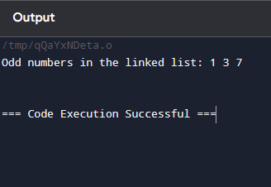
8)#include <stdio.h>
#include <stdlib.h>
#define MAX 100
typedef struct {
int items[MAX];
int front;
int rear;
} Queue;
void initializeQueue(Queue *q) {
q->front = -1;
q->rear = -1;
}
int isEmpty(Queue *q) {
return q->front == -1;
}
int isFull(Queue *q) {
return (q->rear + 1) % MAX == q->front;
}
void enqueue(Queue *q, int value) {
if (isFull(q)) {
printf("Queue is full! Cannot insert %d\n", value);
return;
}
if (isEmpty(q)) {
q->front = 0;
}
q->rear = (q->rear + 1) % MAX;
q->items[q->rear] = value;
printf("Inserted %d into the queue.\n", value);
}
int dequeue(Queue *q) {
if (isEmpty(q)) {
printf("Queue is empty! Cannot delete.\n");
return -1;
}
int data = q->items[q->front];
if (q->front == q->rear) {
q->front = -1;
q->rear = -1;
} else {
q->front = (q->front + 1) % MAX;
}
return data;
}
void displayQueue(Queue *q) {
if (isEmpty(q)) {
printf("Queue is empty!\n");
return;
}
printf("Queue contents: ");
int i = q->front;
while (i != q->rear) {
printf("%d ", q->items[i]);
i = (i + 1) % MAX;
}
printf("%d\n", q->items[i]);
}
int main() {
Queue q;
initializeQueue(&q);
enqueue(&q, 12);
enqueue(&q, 34);
enqueue(&q, 56);
enqueue(&q, 78);
printf("Initial queue: ");
displayQueue(&q);
enqueue(&q, 60);
printf("After insertion of 60: ");
displayQueue(&q);
int deletedElement = dequeue(&q);
printf("Deleted element: %d\n", deletedElement);
printf("After deletion: ");
displayQueue(&q);
return 0;
}
Output:
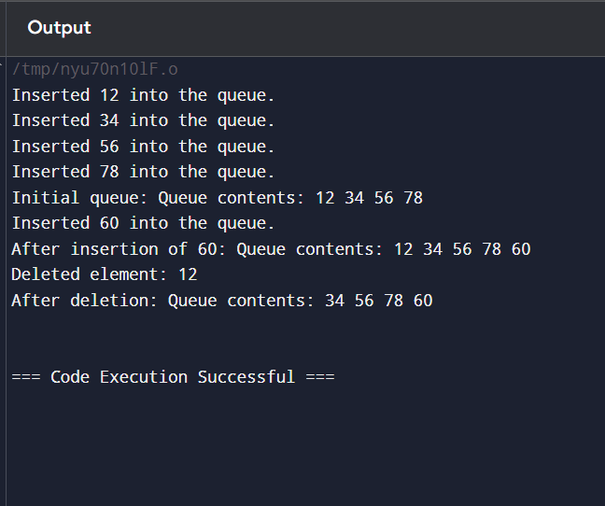

9)#include <stdio.h>
#include <stdbool.h>
#include <string.h>
#define MAX 100
typedef struct {
char items[MAX];
int top;
} Stack;
void initializeStack(Stack *s) {
s->top = -1;
}
bool isEmpty(Stack *s) {
return s->top == -1;
}

bool isFull(Stack *s) {
return s->top == MAX - 1;
}
void push(Stack *s, char value) {
if (isFull(s)) {
printf("Stack overflow!\n");
return;
}
s->items[++s->top] = value;
}
char pop(Stack *s) {
if (isEmpty(s)) {
printf("Stack underflow!\n");
return '\0'; }
return s->items[s->top--];
}
char peek(Stack *s) {
if (isEmpty(s)) {
return '\0';
}
return s->items[s->top];
}
bool isValid(char *s) {
Stack stack;
initializeStack(&stack);
int length = strlen(s);
for (int i = 0; i < length; i++) {
char current = s[i];
if (current == '(' || current == '{' || current == '[') {
push(&stack, current);
}
else if (current == ')' || current == '}' || current == ']') {
if (isEmpty(&stack)) {
return false;
}
char top = pop(&stack);
if ((current == ')' && top != '(') ||
(current == '}' && top != '{') ||
(current == ']' && top != '[')) {
return false;
}
}
}
return isEmpty(&stack);
}
int main() {
char s1[] = "()";
char s2[] = "()[]{}";
char s3[] = "(]";
char s4[] = "([)]";
char s5[] = "{[]}";
printf("Input: %s, Output: %s\n", s1, isValid(s1) ? "true" : "false");
printf("Input: %s, Output: %s\n", s2, isValid(s2) ? "true" : "false");
printf("Input: %s, Output: %s\n", s3, isValid(s3) ? "true" : "false");
printf("Input: %s, Output: %s\n", s4, isValid(s4) ? "true" : "false");
printf("Input: %s, Output: %s\n", s5, isValid(s5) ? "true" : "false");
return 0;
}
Output:
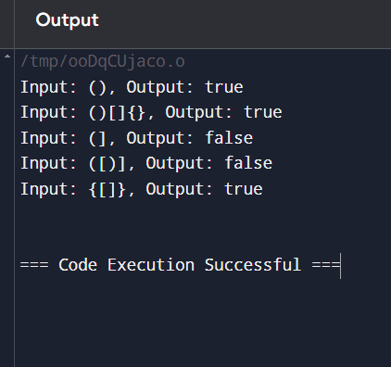

10)#include <stdio.h>
int main() {
int n = 10;
int fib1 = 0, fib2 = 1;
int nextTerm;
int sum = fib1 + fib2;
printf("Fibonacci series: %d, %d", fib1, fib2);
for (int i = 3; i <= n; i++) {
nextTerm = fib1 + fib2;
printf(", %d", nextTerm);
sum += nextTerm;
fib1 = fib2;
fib2 = nextTerm;
}
printf("\nSum: %d\n", sum);
return 0;
}
Output:
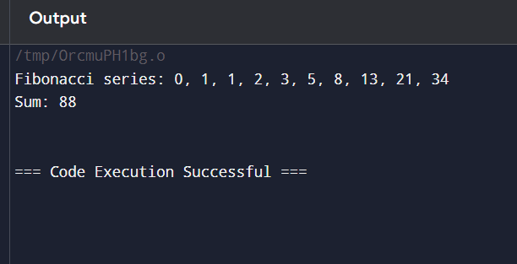

11)#include <stdio.h>
#include <stdlib.h>
struct Node {
int data;
struct Node* next;
};
struct Node* createNode(int data) {
struct Node* newNode = (struct Node*)malloc(sizeof(struct Node));
newNode->data = data;
newNode->next = NULL;
return newNode;
}
int countNodes(struct Node* head) {
int count = 0;
struct Node* current = head;
while (current != NULL) {
count++;
current = current->next;
}
return count;
}

int main() {
struct Node* head = createNode(1);
head->next = createNode(2);
head->next->next = createNode(3);
head->next->next->next = createNode(5);
head->next->next->next->next = createNode(8);
int nodeCount = countNodes(head);
printf("Number of nodes in the linked list: %d\n", nodeCount);
return 0;
}
Output:
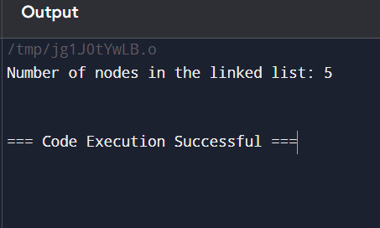

12)#include <stdio.h>
int fibonacci(int n) {
if (n == 0) return 0;
if (n == 1) return 1;
return fibonacci(n - 1) + fibonacci(n - 2);
}
int fibonacciSum(int n) {
if (n == 0) return 0;
return fibonacci(n) + fibonacciSum(n - 1);
}
int main() {
int n = 10;
int sum = 0;
printf("Fibonacci series: ");
for (int i = 0; i < n; i++) {
int fib = fibonacci(i);
printf("%d", fib);
if (i < n - 1) {
printf(", "); }
sum += fib;
}
printf("\nSum: %d\n", sum); // Print the sum of the Fibonacci series
return 0;
}
Output:
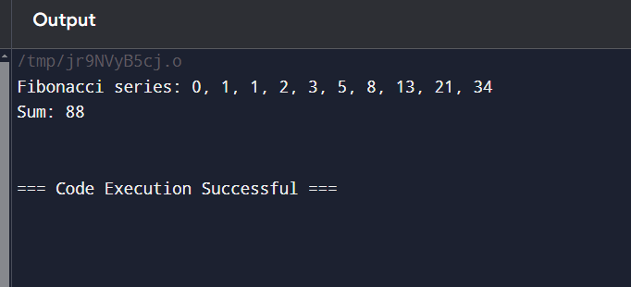

13)#include <stdio.h>
int binarySearch(int arr[], int size, int x) {
int low = 0;
int high = size - 1;
while (low <= high) {
int mid = low + (high - low) / 2;
if (arr[mid] == x) {
return mid;
}
if (arr[mid] < x) {
low = mid + 1;
}
else {
high = mid - 1;
}
}
return -1;
}
int main() {
int arr[] = {1, 5, 6, 7, 9, 10};
int size = sizeof(arr) / sizeof(arr[0]);
int x = 6; // Element to search for
int result = binarySearch(arr, size, x);
if (result != -1) {
printf("Element %d found at location %d\n", x, result);
} else {
printf("Element %d not found in the array\n", x);
}
x = 11;
result = binarySearch(arr, size, x);
if (result != -1) {
printf("Element %d found at location %d\n", x, result);
} else {
printf("Element %d not found in the array\n", x);
}

return 0;
}
Output:
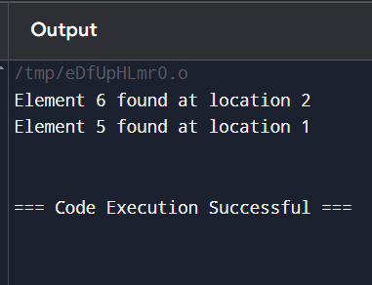

14)#include <stdio.h>
#include <string.h>
#include <stdbool.h>
void sortString(char s[]) {
int len = strlen(s);
for (int i = 0; i < len - 1; i++) {
for (int j = i + 1; j < len; j++) {
if (s[i] > s[j]) {
char temp = s[i];
s[i] = s[j];
s[j] = temp;
}
}
}
}
void findStartingIndices(char s[]) {
int len = strlen(s);
bool repeated = false;
for (int i = 0; i < len; i++) {
if (i < len - 1 && s[i] == s[i + 1]) {
if (!repeated) {
printf("%d", i);
repeated = true;
}
} else {
if (repeated) {
printf(", %d", i + 1);
repeated = false;
}
}
}
printf("\n");
}
int main() {
char s1[] = "tree";
char s2[] = "kkj";
char s3[] = "cccaaa";
char s4[] = "Aabb";
printf("Input: %s\n", s1);
sortString(s1);
printf("Sorted string: %s\n", s1);
printf("Starting index of repeated characters: ");
findStartingIndices(s1);
printf("\nInput: %s\n", s2);
sortString(s2);
printf("Sorted string: %s\n", s2);
printf("Starting index of repeated characters: ");
findStartingIndices(s2);
printf("\nInput: %s\n", s3);
sortString(s3);
printf("Sorted string: %s\n", s3);
printf("Starting index of repeated characters: ");
findStartingIndices(s3);
printf("\nInput: %s\n", s4);
sortString(s4);
printf("Sorted string: %s\n", s4);
printf("Starting index of repeated characters: ");
findStartingIndices(s4);
return 0;
}
Output:
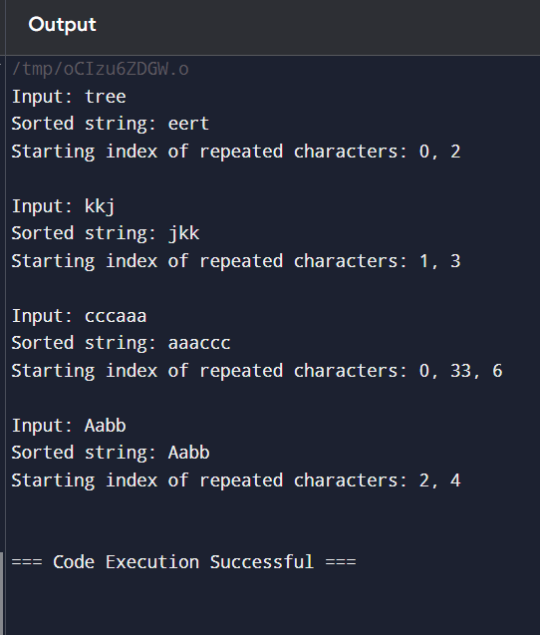
15)#include <stdio.h>
#include <stdlib.h>
#include <stdbool.h>
struct Node {
char data;
struct Node* next;
};
struct Node* createNode(char data) {
struct Node* newNode = (struct Node*)malloc(sizeof(struct Node));
newNode->data = data;
newNode->next = NULL;
return newNode;
}
struct Node* reverseList(struct Node* head) {
struct Node* prev = NULL;
struct Node* current = head;
struct Node* next = NULL;
while (current != NULL) {
next = current->next;
current->next = prev;
prev = current;
current = next;
}
return prev;
}
bool isPalindrome(struct Node* head) {
if (head == NULL || head->next == NULL) {
return true;
}
struct Node* slow = head;
struct Node* fast = head;
while (fast != NULL && fast->next != NULL) {
slow = slow->next;
fast = fast->next->next;
}
struct Node* secondHalf = reverseList(slow);
struct Node* firstHalf = head;
struct Node* copySecondHalf = secondHalf;
while (secondHalf != NULL) {
if (firstHalf->data != secondHalf->data) {
// Restore the list before returning false
reverseList(copySecondHalf);
return false;
}
firstHalf = firstHalf->next;
secondHalf = secondHalf->next;
}
reverseList(copySecondHalf);
return true;
}
void printList(struct Node* head) {
struct Node* current = head;
while (current != NULL) {
printf("%c->", current->data);
current = current->next;
}
printf("NULL\n");
}
int main() {
struct Node* head1 = createNode('1');
head1->next = createNode('2');
head1->next->next = createNode('2');
head1->next->next->next = createNode('1');
printf("Input: 1->2->2->1->NULL\n");
printf("Output: %s\n", isPalindrome(head1) ? "true" : "false");
struct Node* head2 = createNode('1');
head2->next = createNode('2');
printf("Input: 1->2->NULL\n");
printf("Output: %s\n", isPalindrome(head2) ? "true" : "false");
struct Node* head3 = createNode('R');
head3->next = createNode('A');
head3->next->next = createNode('D');
head3->next->next->next = createNode('A');
head3->next->next->next->next = createNode('R');
printf("Input: R->A->D->A->R->NULL\n");
printf("Output: %s\n", isPalindrome(head3) ? "Yes" : "No");
struct Node* head4 = createNode('C');
head4->next = createNode('O');
head4->next->next = createNode('D');
head4->next->next->next = createNode('E');
printf("Input: C->O->D->E->NULL\n");
printf("Output: %s\n", isPalindrome(head4) ? "Yes" : "No");
return 0;
}
Output:
